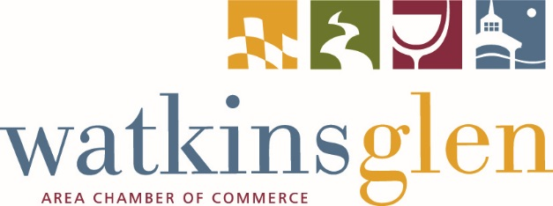
** PRESS RELEASE **
June 24, 2019

Contact: Paul Thomas

Tourism & Marketing Manager

paul@watkinsglenchamber.com

Phone: 607-535-4300

WATKINS GLEN AREA CHAMBER OF COMMERCE
ANNUAL SUMMER RENDEZVOUS – GET YOUR TICKETS TODAY!

WATKINS GLEN, NY – Each year, as the calendar flips to July, we here at the Chamber start looking forward to one of our favorite summer events - the Summer Rendezvous! This is our version of an extra special After Hours Mixer for the month of July.

Date: Wednesday, July 10
Time: 5pm - 8pm
Location: Iroquois Lodge – via the South Entrance (3528 Route 419, Watkins Glen)
3318 Campground Hill Road
Watkins Glen, NY 14891
Sponsor: Chemung Canal Trust Company

What makes the Summer Rendezvous extra special? We'll tell you! First, there is the setting - beautiful Watkins Glen State Park, the Iroquois Lodge, specifically. Our members bring their families, friends, and significant others and it truly becomes a great picnic-style party. Classic lawn games attendees can play will include Ladder Ball, Cornhole, hula hoops and more. Second, there is the meal! The delicious food that The Bucket Bar and Grill will be serving up promises to take barbecue to the next level. Third, there's music by A Walk on the Wildside. Professional chair massages will be available courtesy of Rasa Spa. And in addition, there will be a cash bar with local wine and beer by Barnstormer Winery and Grist Iron Brewing Company. Last, but not least, the annual Celebrity Sack Race ends the night with some lighthearted (and completely hilarious) competition. The winner takes home the coveted Chamber Cup!

Watkins Glen Area Chamber of Commerce CEO/President Rebekah Carroll looks forward to this family-friendly event every year. She shares, “The Summer Rendezvous is one of my favorite annual events. While it is a terrific networking event for our many members, it is also a great chance to get together with our members, families, and friends for some great food, games, and music. It’s a unique event and an evening packed with fun for the whole family!”

TICKETS ARE AVAILABLE NOW!

Courtesy of this year’s event sponsor Chemung Canal Trust Company, Chamber members and their families can receive complimentary tickets if they RSVP before July 9. Tickets includes dinner, non-alcoholic drinks, ice cream, music, and access to all of the fun activities. The laid back atmosphere, family-friendly setting, delicious food, and fun activities promise a memorable evening with family, friends, and colleagues. We hope you'll join us!

###

